Hi and welcome to Clane Wheelers Cycling Club!
To become a member of our club we require just a few pieces of information to process your application.
Name: | DOB:
Email: | Phone:
Address:

Membership fees:
All fees must be processed through our online Banking facility (No cash accepted)
Clane Wheelers Club Membership (Annual Mandatory Payment) - €30
Cycling Ireland Membership (Annual Mandatory Payment) - €45
If you are already a member of cycling Ireland please send on your CI membership details and on the cycling Ireland website change your club over to Clane Wheelers Cycling Club.
Cycling Ireland membership No. (if applicable) :

ICE tag payment (Once off Mandatory requirement) - €10.
For your ICE tag we need the following information:
Contact 1 Name |  | 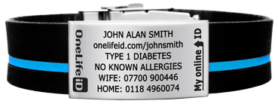
Contact 1 Number
Contact 2 Name
Contact 2 Number
Medical conditions (If any):

All medical information received will be kept in private.

Clane Wheelers Bank Account Information:
A/C No: 66134188
Sort Code: 933236
IBAN: IE13 AIBK 93323666 134188
BIC: AIBKIE2D
When making a payment please add your first name and last initial along with the letters MS

Please e-mail this completed form back to CWCCMembership@gmail.com

